Group Project Individual Report

Botong Wen   
 *Department of Engineering*  
 *King’s College London* London, the United Kingdom  
 K24003185@kcl.ac.uk

# Reflection

In the Miro robot project, I was mainly responsible for the construction of the overall system motion and communication framework, and the development and integration of the emotional interaction, touch interaction and voice interaction modules. We used GitHub for code version control and collaborative development to ensure seamless integration of modules. In terms of project management, I set up a clear time plan and optimized the workflow through regular summaries and adjustments. In terms of time management, to ensure that the project was completed on time, I prioritized the completion of the functional development of the modules because I was responsible for and provided stable data interfaces for other modules. In the system integration phase, I increased the frequency of communication with my teammates to ensure the compatibility and stability of different modules. At the same time, I made a detailed integration test plan and arranged special time for joint debugging and optimization.

Through this project, I realized that the improvement of project efficiency lies in clear task allocation and reasonable time schedule. However, due to the team's poor scheduling of the robot development, the testing time was too tight in the final stage. In addition, in the Gazebo simulation environment, due to the limitation of communication frequency, the simulation situation was different from the actual environment, which affected the result of the project. In the future, I will focus on understanding hardware-simulation differences to enhance integration and performance. This project enhanced my skills in ROS communication, modular design, and multisensory interaction integration. Developing emotion, touch, and voice modules taught me to integrate visual, auditory, and tactile information, improving system intelligence and interactivity.

# Contribution and development

As the touch interaction workflow shown in figure 1, I developed a mechanism for Miro robot to respond to user touch inputs by obtaining and processing data to achieve emotional feedback and behavior performance when touched. The system use the range of body touch and head touch flags from the sensors to specify specific action feedback. The sensors value will not be zero once a touch occurs.

图示

AI 生成的内容可能不正确。

Fig.1 Touch Perception Workflow

In the emotional module, the Miro robot could make different sounds in different mood conditions through modifying valence, arousal, sound level and wakefulness. Then the Miro emits sounds in different mood states, showing the changes in Miro’s mood perception.

In the voice interaction module, speech recognition and semantic analysis algorithms enables Miro to understand and respond to the user's voice commands. According to figure 2, after configuring the audio class with a list of speech, and the robot will perform the corresponding actions according to the recognized speech symbols. Since the voice will always detect the sound, a separate thread is created to prevent blocking the main thread.

图示

AI 生成的内容可能不正确。

Fig.2 Audio Perception Workflow

For the whole system framework construction, I subscribe essential ROS sensors topics and design system motion control structure and data flow to maintain smooth information transfer and collaboration between the different sensors. In the figure 3, each motion interface contains functions corresponding to sensor control, which can be switched to different control states according to the input parameters, and at the same time, different audio, visual, and touch triggered flags can be used to freely combine the corresponding control activities in order to better perceive the environment and feedback. Since the controller method needs to send control information all the time uninterruptedly. controlling the actuator action for a period of time needs to add the parameters like duration, control time and control flag.

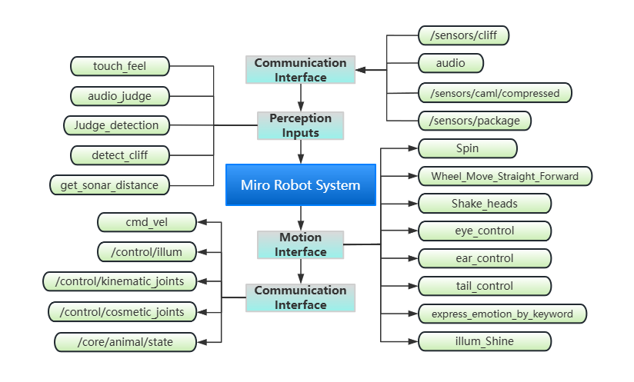

Fig.3 Miro Robot System Structure

# Analyses

Miro’s project is to build a multisensory companion robot system that is capable of sensing environment. By building the control framework, developing the interaction modules and integrating them for testing, the project has achieved the basic functions, but the system lacks stability and real-time performance due to hardware single-threaded limitation and communication method of continuous transmission control. Potential future improvements include optimizing the communication mechanism, introducing deep learning models to improve recognition accuracy, enhancing the ability of multimodal information fusion, to improve the intelligence and interactivity of the system.